Chapter 7

Deep learning directed evolution of anti-mCD25 nanobodies

7.1 Abstract

Bla bla bla

Manuscript in preparation

7.2 Introduction

We can use deep learning not only for small molecules, but also for biologics

Immune modulators are very promising, for example for cancer

However, modulating the immune system in an untargeted manner can result in immune-related off-target toxicity.

Nanoparticles -> aNP

Inherent affinity for myeloid cells (macrophages, dendritic cells, monocytes, and neutrophils)

We can add an additional target moiety to expand their therapeutic use

The final chapter of this thesis presents a distinct but conceptually related project: the generative design of nanobody sequences using large language models. While the molecular modality (protein vs. small molecule) and the task (generation vs. prediction) differ from earlier chapters, the methodological challenges — learning under data scarcity, generalizing beyond training distributions, and leveraging uncertainty for decision-making — remain central. This work represents a step toward integrating predictive and generative tools in the molecular design cycle.

While earlier chapters explored how to build robust models for molecular property prediction and decision-making under uncertainty, this chapter investigates whether such models can be used to proactively generate biologically relevant molecules — in this case, nanobody sequences with likely target affinity.

Just like in small molecule screening, nanobody discovery is constrained by data scarcity and the need to generalize beyond known binders. This chapter applies similar machine learning principles — such as transfer learning and likelihood-based acquisition — to a different molecular modality.

This chapter illustrates how the same data-driven principles developed for chemical structure-based learning can be adapted to other biomolecular systems — here, protein sequences — highlighting the generality of molecular machine learning approaches.

Introduction to nanobodies

- Briefly define nanobodies (single-domain antibodies from camelids).
- Mention their advantages over conventional antibodies (size, stability, ease of expression).
- State their emerging importance in therapeutics and diagnostics.

Nanobodies are the variable heavy chain (VHH) domains of camelid antibodies. Unlike conventional antibodies, which require both heavy and light chains, nanobodies are composed of a single domain capable of high-affinity target binding. Their small size (~15 kDa), high solubility, and robust stability have made them attractive candidates for therapeutic and diagnostic applications, particularly in immune-oncology and targeted delivery systems.

The role of CDR loops in binding
- Introduce the concept of Complementarity Determining Regions (CDRs).
- Explain the biological function of CDR1–3, with a note on CDR3 being the most variable and critical.
- Clarify that the framework regions are structurally conserved and often reused.
Target recognition in nanobodies is mediated by three hypervariable loops known as the complementarity-determining regions (CDR1, CDR2, and CDR3), which form the antigen-binding site. Among these, CDR3 exhibits the greatest sequence and structural variability, typically contributing most to antigen specificity. The surrounding framework regions provide structural support but are largely conserved across nanobodies.

Target and Experimental Context
- Introduce murine CD25 (mCD25) as the target used for fine-tuning.
- Mention why mCD25 is relevant: well-characterized immune marker, expressed on activated and regulatory T cells.
- Describe the experimental setup briefly: yeast display to identify weak binders to mCD25.
In this study, nanobody generation was performed against murine CD25 (mCD25), the alpha chain of the interleukin-2 receptor. mCD25 is expressed on activated T cells and regulatory T cells (Tregs), and serves as an important immune marker. A set of weak mCD25-binding nanobodies was identified using yeast surface display and subsequently used for model fine-tuning.

Challenges in Binder Discovery and Optimization
- Describe the limitations of traditional affinity maturation (mutagenesis + selection).
- Highlight the need for diverse, high-affinity binders.
- Motivate the use of ML to complement experimental screening.
Traditional affinity maturation via yeast or phage display involves laborious iterative cycles of mutagenesis and selection, often exploring only a narrow local region of sequence space. In contrast, machine learning models can accelerate binder discovery by proposing diverse, syntactically plausible, and target-specific sequences in silico.

Generative Modeling with LLMs
- Briefly describe the concept of training a language model on nanobody sequences.
- Mention the benefit of learning the “syntax” of nanobodies from large pretraining corpora.
- Introduce the idea of fine-tuning on weak binders to steer generation toward target-specific binders.
We pretrained an autoregressive language model on millions of natural nanobody sequences to learn their underlying ‘grammar’ — the patterns and constraints that define viable CDR loop combinations. The model was then fine-tuned on a small set of experimentally selected weak binders for mCD25 to bias generation toward plausible target-specific designs.

Goal and Contribution of This Chapter
- Clearly state your contribution.
- Mention that the generated sequences have not been experimentally validated yet but represent a new path for affinity maturation.
This chapter presents a generative modeling approach for target-specific nanobody design using large-scale pretraining and data-efficient fine-tuning. Although experimental validation of the generated sequences is pending, this work illustrates a machine learning pipeline for virtual affinity maturation, enabling rapid design of novel, target-biased nanobody sequences.

By introducing a targeting moiety, such as a nanobody, fused to apoA1, the distribution of aNPs can be redirected away from myeloid cells towards a different cell type.

<Antibody, Nanobody, CDR loops, nanobiologic>
Figure 7.1 | Nanobiologics and how to generate them.

7.3 Results

In what follows, we will

Why Model CDR Loops Only
- Framework regions are constant and not modeled.
- The model focuses exclusively on generating CDR1–3, which encode binding information.
- Reduces sequence redundancy and model complexity.

Pretraining
Before designing target-specific CDR3 loops, we pretrained a large language model to learn the general nanobody ‘syntax’ using 7.4M nanobody sequences without specific binding information (Fig. 1). Our model generates sequences containing just CDR loops (omitting framework regions). We evaluated the generative performance of our pretrained model by analyzing its designs that are sampled using temperature sampling. Our model achieves a uniqueness of 0.768 and a novelty of 0.629 for a temperature of t=1, which is comparible to exisiting literature¹. By increasing the sampling temperature, designs become more unique and novel (Fig. 1d,e). A higher temperature allows for more ‘creativity’ in sampled designs by moving away from the models original learned probability landscape (t=1). Due to the untargeted nature of the pretraining data, detailed evaluation of CDR motifs is infeasible. However, as a santity check, pysicochemical property distributions of designs match distributions from the test set, while being more dissimilar to control sequences designed with a simple statistical method in comparison (Supp Fig. 1).

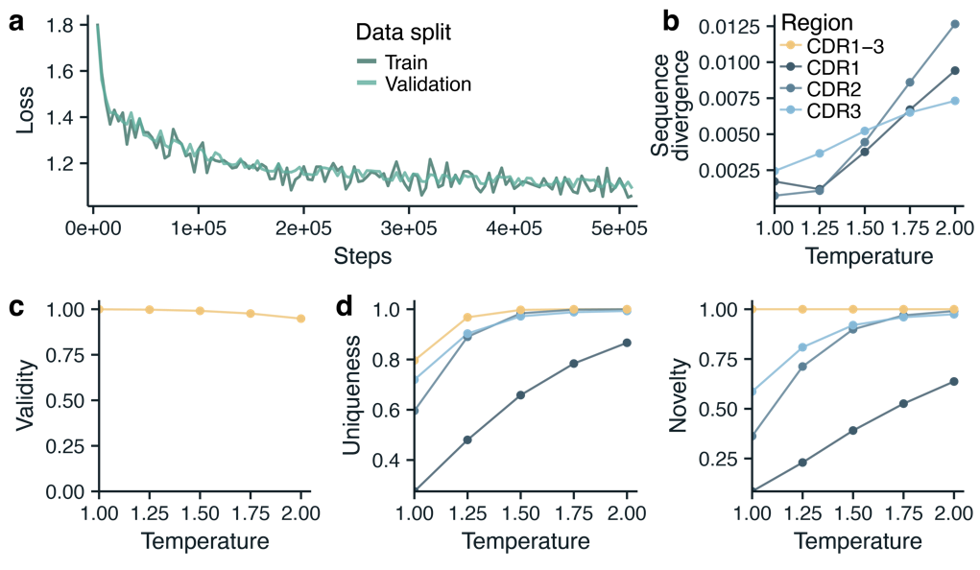
Fig 1 | Generative performance of the pretrained model. a, Model losses during training. b, Jensen-Shannon divergence ($D_{JS}$) between generated nanobody sequences and the test set across different sampling temperatures. c, Validity of generated nanobody sequences across different temperatures. d, Uniqueness (fraction of unique designs) of nanobody designs across different temperatures, measured on valid sequences. e, Novelty (fraction of designs not occuring in the training set) of nanobody designs across different temperatures, measured on valid sequences. Metrics in c-e are calculated on n=100,000 designs.

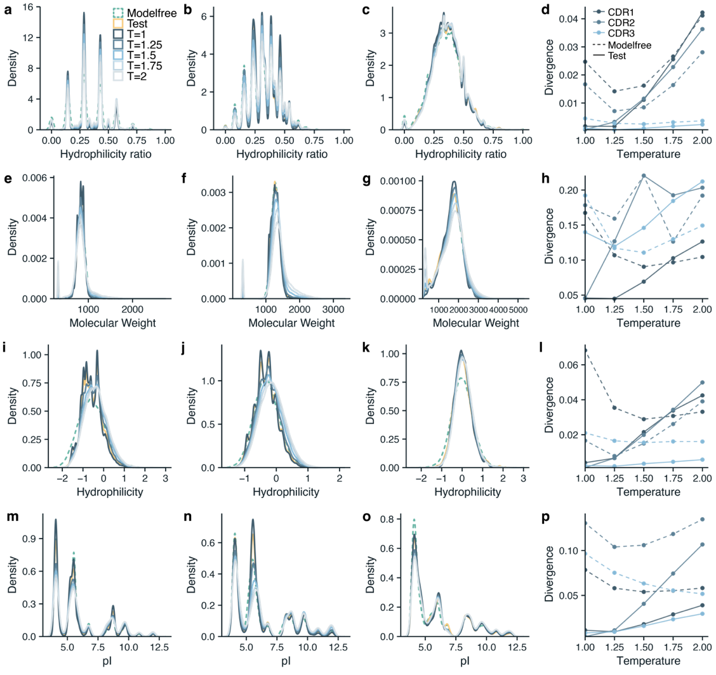
Supplementary figure 1 | Phyicochemical properties of CDR regions generated by the pretrained model. Property distributions of generated CDR region 1-3 for different sampling temperatures in comparison to test set sequences or modelfree designs. All metrics are calculated using n=100,000 designs. a-c, Distributions of the ratio between hydrophilic and hydrophobic amino acids. d, Jensen-Shannon divergence ($D_{JS}$) between the hydrophilicity ratio distributions of generated CDR regions across different sampling temperatures in relation to test set sequences or modelfree designs. e-g, Distributions of molecular weight. h, Jensen-Shannon divergence of molecular weight distributions. i-k, Distributions of CDR regions hydrophilicity. l, Jensen-Shannon divergence of hydrophilicity distributions. m-o, Distributions of the isoelectric point (pI) of CDR regions. p, Jensen-Shannon divergence of isoelectric point distributions.

Pretraining Finetuning on binders
A set of 8,816 nanobody binders was used to finetune the pretrained model (Fig. 3a, b). Using the finetuned model, 100,000 nanobody sequences were generated. From these generations, 99.8% was valid, 62.9% was unique, and 71.7% and 100% was novel in relation to the finetuning or pretraining data respectively (Table 1). Ideally, these sequences are similar to the finetuning data of nanobody binders and have moved away from the pretraining data that did not contain specific binding information. Comparing model negative log likelihoods (NLL, eq. 1) of the generated sequences and sequences in the finetuning and pretraining data (Fig. 3c), we see that generated sequences achieve similar NLL values as sequences in the finetune data. Sequences in the pretrain data or control sequences, on the other hand, yield high (worse) NLL values. Looking at physicochemical properties, computed hydrophilicity of CDR regions of generated sequences have shifted towards the properties of the finetune data (Fig. 3d-f). Finally, global CDR1, 2, and 3 sequence motifs of the generated sequences are highly similar to the finetuning data and dissimilar to the pretrianing data (Fig. 4). At the same time, motifs of the generated sequences are not identical to the finetuning data, both globablly (Fig. 4) and in enriched k-mers (Fig. ?). This shows that the finetuned model has learned the global properties of binders according to the finetuning data, while still having the ability to generate novel sequences.

Design acquisition
From the generated sequences, the 900 best scoring valid, unique, and novel designs were selected for follow-up. Generated sequences were selected by their corrected negative log likelihood value (eq. 7, Fig. 3g) using greedy acquisition (eq. 8). The top ranked designs proved to contain particularly similar sequence compositions to the finetune data, while still being novel in structure (Fig. 4), which is desirable. Alongside the top ranked designs, the 100 best scoring (eq. 7) sequences from the finetuning data were selected.

Table 1 | Generative performance metrics of the finetuned model. A total of 100,000 sequences were generated.
 | CDR1-3 | CDR1 | CDR2 | CDR3
Validity | 0.998 | 1 | 1 | 1
Uniqueness | 0.629 | 0.037 | 0.079 | 0.115
Novelty (finetune) | 0.717 | 0.063 | 0.129 | 0.140
Novelty (pretrain) | 1.000 | 0.991 | 0.908 | 0.999

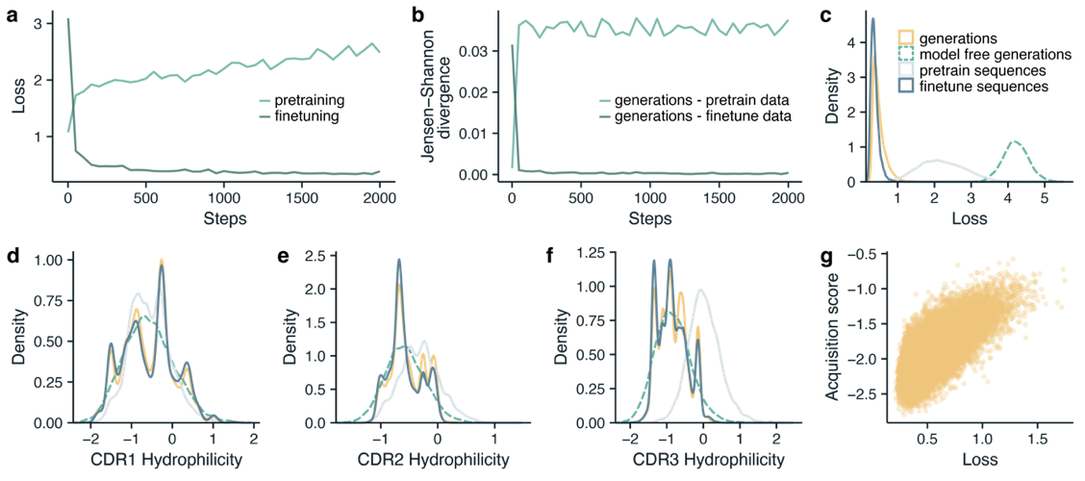
Fig 3 | Finetuning of the pretrained model. a, Negative log likelihood loss on the pretraining and finetuning set during finetuning. b, Jensen-Shannon divergence between generated sequences and the pretrain or finetuning set during finetuning. c, Loss landscape of the finetuned model between data sets. d-f, Sequence hydrophilicity between datasets and the finetuned model for CDR1-3. All datasets in c-f are randomly subsampled to n=8,816 to match the size of the finetuning set. g, Losses of unique generated sequences compared to their corrected acquisition score (eq. 7).
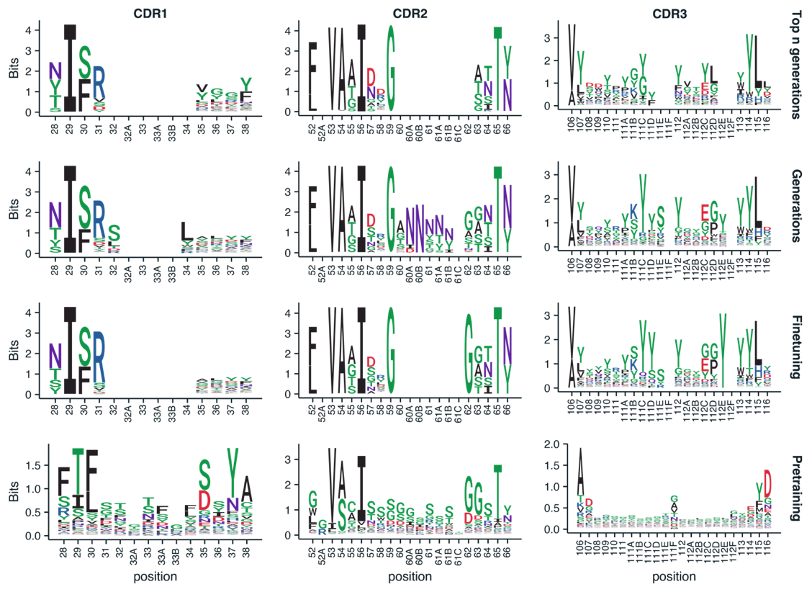
Fig 4 | Sequence logos. Columns correspond to aligned sequences from CDR1, CDR2, and CDR3 regions from left to right. Rows correspond to the top 900 generations selected for follow-up, all generated sequences, all sequences in the finetuning set, and all sequences in the pretraining set, from top to bottom.

7.4 Discussion
This study ...

7.5 Methods

Data processing.
Defining CDR regions. CDR regions were defined according the the IMGT definition² with a numbering shift according to McMahon et al.³ to incoreperate variability of several amino acids in the framework regions. CDR1 IMGT positions were shifted from 27-38 to 28-38, CDR2 positions from 56-65 to 52-66, and CDR3 positions from 105-117 to 106-116.

Pretraining data. Nanobody sequences from the Integrated Nanobody Database for Immunoinformatics (INDI)⁴ were used. Sequences from INDI sourced from patents, GenBank, the Protein Data Bank (PDB), Next-Generation Sequencing, and manual curation were aggregated into one corpus of 11,246,884 sequences. For all sequences, INDI reports framework regions and CDR loops according to the IMGT² numbering scheme^{4,5}. We corrected reported CDR regions according to McMahon et al.³ as described above. Since framework regions are constant in our experimental setup, sequences were curated by their CDR regions only. Sequence were omitted if they contained non-canonical amino acids, had a CDR loop smaller than 3 or larger than 30 amino acids, or when the CDR1, CDR2, and CDR3 loops combined exceeded 70 amino acids. This excluded 157,650 nanobodies. Next, 3,482,873 non-unique sequences (CDR1, CDR2, and CDR3 combined) were removed. From the remaining data, a validation set (n=100,000) and test set (n=100,000) was sampled using uniform sampling, leaving n=7,406,361 nanobody sequences in the training set.

Finetuning data. Nanobody binders were processed identically to the pretraining data. For the first finetuning round, 8,816 sequences remained after cleaning.

Sequence encoding. All sequences were encoded by omitting all framework regions and concatenating the CDR loops, isolated by a separator token. A encoding length of 70 tokens was used with an encoding vocabulary (n=24) containing all twenty canonical amino acids, a start token, seperator token, end token, and a padding token (to pad sequences shorter than the encoding length), e.g., “:NISSGRN|FVATIDSGSSTY|AVYVYGYTHY;________________
_____________________”. Since our vocabulary is small and CDR loops are hypervariable by definition, we did not implement byte-pair encoding.

Machine learning.
Pretraining. A decoder only autoregressive Transformer⁶ was implemented according to the GTP2 architecture⁷. Using next-token prediction, the model was trained with a length-normalized negative log-likelihood loss

$$L=\frac{1}{N}\sum_{i=1}^{N}{-\log{p\left(t_{i}|t_{<i}\right)}}\text{,}$$ | (1)
where $t_{i}$ is the $i-th$ non-padding token and $N$ are all non-padding tokens in a sequence. Since CDR loop seperator tokens and the end-of-sequence token carry semantic meaning, they were included in the loss calculation. The model was trained with mixed precision using the AdamW optimizer with $β_{1} = 0.9$, $β_{2} = 0.99$, and a weight decay of 0.1. Weight decay was not applied to biases, layer normalization, or embedding weights. A dropout of 0.4 was used on attention weights, residual connection weights, and embedding weights. Gradients with a L2 norm exceeding 1.0 were clipped. To train the model, mini-batches of 256 nanobody sequences were sampled from the training data for up to 1,000,000 training steps using uniform sampling. Every 4,000 training steps (i.e., every ~1M samples), models were validated on the full validation set. Early stopping was implemented using a patience of 10 validation steps by monitoring the loss (eq. 1) on the validation set. Using this training setup, grid-search was used to optimize the following hyperparameters: number of transformer layers = [4, 6, 8, 12], number of attention heads = [4, 6, 8, 12], embedding size = [192, 384], and learning rate = [${3 × 10}^{-4}$, ${3 × 10}^{-5}$, ${3 × 10}^{-6}$]. The model with the best validation loss was used (12 layers, 12 attention head, and a learning rate of ${3 × 10}^{-4}$).

Nanobody generation. Nanobody sequences were generated by using autoregressive temperature sampling: the next token is sampled from the model’s predicted probability distribution based on the previous tokens, starting with the start token. As during training, CDR1-3 sequences were generated together as one sequence (including the CDR separator tokens). The sampling probability of each $i$-th token

$$p_{i}=\frac{e^{\left(Z_{i}/T\right)}}{\sum_{j}^{n}{e^{\left(Z_{j}/T\right)}}}\text{,}$$ | (2)

where $Z_{i}$ are the token logits sampled from the model, $T$ is the temperature, and $Z_{j}$ is the $j-th$ token in the vocabulary.

Finetuning. Sequenced binders were used to finetune the pretrained model using the same training strategy described earlier. However, a learning rate of ${3 × 10}^{-5}$ was used, together with a batch size of 32, and a weight decay of 0.01.

During fine-tuning, the loss (eq. 1) on the pretraining validation set and finetuning set was monitored every 50 batches. Alongside, the differences in amino acid prevalence between generated sequences (n=10,000) and reference sets (n=10,000, uniformly sampled) were monitored. Given the set of all twenty canonical amino acids 𝒜 in all generated sequences $S_{gen}$ and a reference set $S_{ref}$, the probability distributions $P$ and $Q$ were calculated as

$$P\left(a\right)=\frac{n_{a}\text{ in }S_{gen}}{N_{S_{gen}}} \text{ and } Q\left(a\right)=\frac{n_{a}\text{ in }S_{ref}}{N_{S_{ref}}}, ∀a∈A\text{,}$$ | (3)

where $n_{a}$ is the occurence of amino acid $a$ in the set and $N$ is the total number of amino acids in the set. Using the mixture distribution

$$M(a)=\frac{1}{2}(P(a)+Q(a))\text{,}$$ | (4)

the Jensen-Shannon Divergence ($D_{JS}$) between $P$ and $Q$ can then be calculated as:

$$D_{JS}(P∥Q)=\frac{1}{2}D_{KL}(P∥M) + \frac{1}{2}D_{KL}(Q∥M)\text{,}$$ | (5)
where $D_{KL}$ is the Kullback-Leibler divergence, defined as

$$D_{KL}\left(P∥Q\right) = \sum_{a∈A}{P\left(a\right) }\log\left(\frac{P\left(a\right)}{Q\left(a\right)}\right).$$ | (6)
Finetuning was performed until the loss on the finetuning set stopped improving and $D_{JS}$ between the designs and the finetune set is lower than $D_{JS}$ between designs and the pretraining validation set.

Design acquisition.
Using temperature sampling with a temperature of 1, n=100,000 nanobody sequences were generated. For each design, the normalized log-likelihood⁸ was computed over each individual sequence (eq. 1). To correct for potential pretraining bias⁸, a debiased acquisition score $L_{score}$ was computed, considering both the pretrained model and the finetuned model:

$L_{score}= L_{finetune}-L_{pretrain}$. | (7)

Using the acquisition function

${acq = {argmin}_{n}(L}_{score})$, | (8)

the n=100 best scoring nanobody sequences from the finetuning set and the best n=900 valid, unique, and novel generated nanobody sequences were selected for follow-up.

Design evaluation.
Evaluation metrics. Generated designs were evaluated by computing several statistics and properties. Validity was defined as the fraction of designs where the CDR loop seperator tokens and end-of-sequence token) were placed correctly. Uniqueness is defined as the fraction of unique valid sequences among the generated designs. Novelty is the fraction of valid sequences that are not present in the training set. Hydrophilicity profiles of sequences were determined using the Hopp-Woods scale. Isoelectric point was calculated using the Biopython package (1.84).

Nanobody sequence alignment. Nanobody sequences were aligned with ANARCI (1.3)⁹ according to the IMGT scheme for Lama pacos. Alignment on generated CDR loops was done by creating a full nanobody sequence first by concatenating the CDR loops with the most common framework sequences for each respective framework region from our NGS data.

Motif enrichment analysis. A simple k-mer enrichment analyisis was performed, comparing k-mer enrichment between different sets of ungapped sequences. First, all occuring k-mers (k=3-20) were found, after which the presence of each k-mer in all sequences was counted. Enrichment was tested with a two-sided bionominal test a bonferroni correction (α=0.05) for multiple testing correction.

Random sequence control. A model-free nanobody sequence generation method was implemented that samples amino acids according to their occurrence in the training data. For each set of CDR loop sequences $S_{CDR}$ in the training data, a length distribution$P(l)$ and an amino acid distribution $P(a), ∀a∈A\text{,}$ was fitted (eq. 3). For each generated design, its length $l$ was sampled from $P(l)$, after which $l$ amino acids were sampled from $P(a)$ independent of the position.

Hardware and training setup
All computations were performed on a Lenovo ThinkSystem SD650-N v2 server equipped with Intel Xeon Platinum 8360Y CPUs and NVIDIA A100 (40GB) GPUs.

7.6 Appendix

7.7 References

1. Gawehn, E., Hiss, J. A. & Schneider, G. Deep Learning in Drug Discovery. Molecular Informatics 35, 3–14 (2016).
2. Jiménez-Luna, J., Grisoni, F., Weskamp, N. & Schneider, G. Artificial intelligence in drug discovery: recent advances and future perspectives. Expert Opinion on Drug Discovery 16, 949–959 (2021).
3. Vamathevan, J. et al. Applications of machine learning in drug discovery and development. Nat Rev Drug Discov 18, 463–477 (2019).
4. Stokes, J. M. et al. A Deep Learning Approach to Antibiotic Discovery. Cell 180, 688-702.e13 (2020).
5. Liu, G. et al. Deep learning-guided discovery of an antibiotic targeting Acinetobacter baumannii. Nat Chem Biol (2023) doi:10.1038/s41589-023-01349-8.
6. Walters, W. P., Stahl, M. T. & Murcko, M. A. Virtual screening—an overview. Drug Discovery Today 3, 160–178 (1998).
7. Yera, E. R., Cleves, A. E. & Jain, A. N. Chemical Structural Novelty: On-Targets and Off-Targets. J. Med. Chem. 54, 6771–6785 (2011).
8. Wills, T. J. & Lipkus, A. H. Structural Approach to Assessing the Innovativeness of New Drugs Finds Accelerating Rate of Innovation. ACS Med. Chem. Lett. 11, 2114–2119 (2020).
9. Shimizu, Y. et al. AI-driven molecular generation of not-patented pharmaceutical compounds using world open patent data. J Cheminform 15, 120 (2023).
10. Atanasov, A. G. et al. Natural products in drug discovery: advances and opportunities. Nat Rev Drug Discov 20, 200–216 (2021).
11. Wright, G. D. The antibiotic resistome: the nexus of chemical and genetic diversity. Nat Rev Microbiol 5, 175–186 (2007).
12. Ji, Y. et al. DrugOOD: Out-of-Distribution (OOD) Dataset Curator and Benchmark for AI-aided Drug Discovery -- A Focus on Affinity Prediction Problems with Noise Annotations. Preprint at https://doi.org/10.48550/ARXIV.2201.09637 (2022).
13. Dias, A. L., Bustillo, L. & Rodrigues, T. Limitations of representation learning in small molecule property prediction. Nat Commun 14, 6394 (2023).
14. Tossou, P., Wognum, C., Craig, M., Mary, H. & Noutahi, E. Real-World Molecular Out-Of-Distribution: Specification and Investigation. J. Chem. Inf. Model. 64, 697–711 (2024).
15. Martinez-Mayorga, K. et al. The pursuit of accurate predictive models of the bioactivity of small molecules. Chem. Sci. 15, 1938–1952 (2024).
16. Grygorenko, O. O. et al. Generating Multibillion Chemical Space of Readily Accessible Screening Compounds. iScience 23, 101681 (2020).
17. Nigam, A. et al. Assigning confidence to molecular property prediction. Expert Opinion on Drug Discovery 16, 1009–1023 (2021).
18. Nada, H., Meanwell, N. A. & Gabr, M. T. Virtual screening: hope, hype, and the fine line in between. Expert Opinion on Drug Discovery 1–18 (2025) doi:10.1080/17460441.2025.2458666.
19. Hanser, T., Barber, C., Marchaland, J. F. & Werner, S. Applicability domain: towards a more formal definition. SAR and QSAR in Environmental Research 27, 865–881 (2016).
20. Mathea, M., Klingspohn, W. & Baumann, K. Chemoinformatic Classification Methods and their Applicability Domain. Molecular Informatics 35, 160–180 (2016).
21. Wang, Z. & Chen, J. Applicability Domain Characterization for Machine Learning QSAR Models. in Machine Learning and Deep Learning in Computational Toxicology (ed. Hong, H.) 323–353 (Springer International Publishing, Cham, 2023). doi:10.1007/978-3-031-20730-3_13.
22. Wang, D. et al. Learning with uncertainty to accelerate the discovery of histone lysine-specific demethylase 1A (KDM1A/LSD1) inhibitors. Briefings in Bioinformatics 24, bbac592 (2023).
23. Soleimany, A. P. et al. Evidential Deep Learning for Guided Molecular Property Prediction and Discovery. ACS Cent. Sci. 7, 1356–1367 (2021).
24. Ovadia, Y. et al. Can you trust your model’ s uncertainty? Evaluating predictive uncertainty under dataset shift. in Advances in Neural Information Processing Systems vol. 32 (Curran Associates, Inc., 2019).
25. Scalia, G., Grambow, C. A., Pernici, B., Li, Y.-P. & Green, W. H. Evaluating Scalable Uncertainty Estimation Methods for Deep Learning-Based Molecular Property Prediction. J. Chem. Inf. Model. 60, 2697–2717 (2020).
26. Grisoni, F. et al. Combining generative artificial intelligence and on-chip synthesis for de novo drug design. Sci. Adv. 7, eabg3338 (2021).
27. Gómez-Bombarelli, R. et al. Automatic Chemical Design Using a Data-Driven Continuous Representation of Molecules. ACS Cent. Sci. 4, 268–276 (2018).
28. Merk, D., Friedrich, L., Grisoni, F. & Schneider, G. De Novo Design of Bioactive Small Molecules by Artificial Intelligence. Molecular Informatics 37, 1700153 (2018).
29. Merk, D., Grisoni, F., Friedrich, L. & Schneider, G. Tuning artificial intelligence on the de novo design of natural-product-inspired retinoid X receptor modulators. Commun Chem 1, 1–9 (2018).
30. Hinton, G. E. & Salakhutdinov, R. R. Reducing the Dimensionality of Data with Neural Networks. Science 313, 504–507 (2006).
31. Iovanac, N. C. & Savoie, B. M. Simpler is Better: How Linear Prediction Tasks Improve Transfer Learning in Chemical Autoencoders. J. Phys. Chem. A 124, 3679–3685 (2020).
32. Kingma, D. P., Rezende, D. J., Mohamed, S. & Welling, M. Semi-Supervised Learning with Deep Generative Models. Preprint at https://doi.org/10.48550/ARXIV.1406.5298 (2014).
33. Doersch, C. & Zisserman, A. Multi-task Self-Supervised Visual Learning. in 2017 IEEE International Conference on Computer Vision (ICCV) 2070–2079 (IEEE, Venice, 2017). doi:10.1109/ICCV.2017.226.
34. Assran, M. et al. Self-Supervised Learning from Images with a Joint-Embedding Predictive Architecture. in 2023 IEEE/CVF Conference on Computer Vision and Pattern Recognition (CVPR) 15619–15629 (IEEE, Vancouver, BC, Canada, 2023). doi:10.1109/CVPR52729.2023.01499.
35. Kim, D., Yoo, Y., Park, S., Kim, J. & Lee, J. SelfReg: Self-supervised Contrastive Regularization for Domain Generalization. in 2021 IEEE/CVF International Conference on Computer Vision (ICCV) 9599–9608 (IEEE, Montreal, QC, Canada, 2021). doi:10.1109/ICCV48922.2021.00948.
36. Sun, Y. et al. Test-Time Training with Self-Supervision for Generalization under Distribution Shifts. in Proceedings of the 37th International Conference on Machine Learning 9229–9248 (PMLR, 2020).
37. Albuquerque, I., Naik, N., Li, J., Keskar, N. & Socher, R. Improving out-of-distribution generalization via multi-task self-supervised pretraining. Preprint at https://doi.org/10.48550/ARXIV.2003.13525 (2020).
38. Pimentel, M. A. F., Clifton, D. A., Clifton, L. & Tarassenko, L. A review of novelty detection. Signal Processing 99, 215–249 (2014).
39. Zhou, Y. Rethinking Reconstruction Autoencoder-Based Out-of-Distribution Detection. in 2022 IEEE/CVF Conference on Computer Vision and Pattern Recognition (CVPR) 7369–7377 (IEEE, New Orleans, LA, USA, 2022). doi:10.1109/CVPR52688.2022.00723.
40. Chalapathy, R. & Chawla, S. Deep Learning for Anomaly Detection: A Survey. Preprint at https://doi.org/10.48550/ARXIV.1901.03407 (2019).
41. Ruff, L. et al. Deep Semi-Supervised Anomaly Detection. Preprint at https://doi.org/10.48550/ARXIV.1906.02694 (2019).
42. Weininger, D. SMILES, a chemical language and information system. 1. Introduction to methodology and encoding rules. J. Chem. Inf. Comput. Sci. 28, 31–36 (1988).
43. Jastrzębski, S., Leśniak, D. & Czarnecki, W. M. Learning to SMILE(S). Preprint at https://doi.org/10.48550/ARXIV.1602.06289 (2016).
44. Özçelik, R. & Grisoni, F. A hitchhiker’s guide to deep chemical language processing for bioactivity prediction. Digital Discovery 10.1039.D4DD00311J (2025) doi:10.1039/D4DD00311J.
45. Gaulton, A. et al. ChEMBL: a large-scale bioactivity database for drug discovery. Nucleic Acids Research 40, D1100–D1107 (2012).
46. Pearce, T., Leibfried, F. & Brintrup, A. Uncertainty in Neural Networks: Approximately Bayesian Ensembling. in Proceedings of the Twenty Third International Conference on Artificial Intelligence and Statistics 234–244 (PMLR, 2020).
47. Reutlinger, M. et al. Chemically Advanced Template Search (CATS) for Scaffold‐Hopping and Prospective Target Prediction for ‘Orphan’ Molecules. Molecular Informatics 32, 133–138 (2013).
48. Van Tilborg, D., Alenicheva, A. & Grisoni, F. Exposing the Limitations of Molecular Machine Learning with Activity Cliffs. J. Chem. Inf. Model. 62, 5938–5951 (2022).
49. Tran-Nguyen, V.-K., Jacquemard, C. & Rognan, D. LIT-PCBA: An Unbiased Data Set for Machine Learning and Virtual Screening. J. Chem. Inf. Model. 60, 4263–4273 (2020).
50. Hansen, K. et al. Benchmark Data Set for in Silico Prediction of Ames Mutagenicity. J. Chem. Inf. Model. 49, 2077–2081 (2009).
51. Manelfi, C. et al. “Molecular Anatomy”: a new multi-dimensional hierarchical scaffold analysis tool. J Cheminform 13, 54 (2021).
52. Maggiora, G., Vogt, M., Stumpfe, D. & Bajorath, J. Molecular Similarity in Medicinal Chemistry. J. Med. Chem. 57, 3186–3204 (2014).
53. Rogers, D. & Hahn, M. Extended-Connectivity Fingerprints. J. Chem. Inf. Model. 50, 742–754 (2010).
54. Cereto-Massagué, A. et al. Molecular fingerprint similarity search in virtual screening. Methods 71, 58–63 (2015).
55. Rossen, L., Sirockin, F., Schneider, N. & Grisoni, F. Scaffold Hopping with Generative Reinforcement Learning. Preprint at https://doi.org/10.26434/chemrxiv-2024-gd3j4 (2024).
56. Fooladi, H., Vu, T. N. L. & Kirchmair, J. Evaluating Machine Learning Models for Molecular Property Prediction: Performance and Robustness on Out-of-Distribution Data. Preprint at https://doi.org/10.26434/chemrxiv-2025-g1vjf-v2 (2025).
57. Lee, K., Lee, K., Lee, H. & Shin, J. A Simple Unified Framework for Detecting Out-of-Distribution Samples and Adversarial Attacks. Preprint at https://doi.org/10.48550/ARXIV.1807.03888 (2018).
58. Boix-Adsera, E., Lawrence, H., Stepaniants, G. & Rigollet, P. GULP: a prediction-based metric between representations. Advances in Neural Information Processing Systems 35, 7115–7127 (2022).
59. Gunantara, N. A review of multi-objective optimization: Methods and its applications. Cogent Engineering 5, 1502242 (2018).
60. Welsch, M. E., Snyder, S. A. & Stockwell, B. R. Privileged scaffolds for library design and drug discovery. Current Opinion in Chemical Biology 14, 347–361 (2010).
61. Roskoski, R. Properties of FDA-approved small molecule protein kinase inhibitors: A 2024 update. Pharmacological Research 200, 107059 (2024).
62. Wu, P., Nielsen, T. E. & Clausen, M. H. FDA-approved small-molecule kinase inhibitors. Trends in Pharmacological Sciences 36, 422–439 (2015).
63. Xu, L. et al. Recent Research Advances in Small-Molecule Pan-PIM Inhibitors. Pharmaceutical Fronts 04, e207–e222 (2022).
64. Bickerton, G. R., Paolini, G. V., Besnard, J., Muresan, S. & Hopkins, A. L. Quantifying the chemical beauty of drugs. Nature Chem 4, 90–98 (2012).
65. Ertl, P. & Schuffenhauer, A. Estimation of synthetic accessibility score of drug-like molecules based on molecular complexity and fragment contributions. J Cheminform 1, 8 (2009).
66. Wallach, I. & Heifets, A. Most Ligand-Based Classification Benchmarks Reward Memorization Rather than Generalization. J. Chem. Inf. Model. 58, 916–932 (2018).
67. Holman, L., Head, M. L., Lanfear, R. & Jennions, M. D. Evidence of Experimental Bias in the Life Sciences: Why We Need Blind Data Recording. PLoS Biol 13, e1002190 (2015).
68. Yoshizawa, T. et al. A data-driven generative strategy to avoid reward hacking in multi-objective molecular design. Nat Commun 16, 2409 (2025).
69. Van Tilborg, D. & Grisoni, F. Traversing chemical space with active deep learning for low-data drug discovery. Nat Comput Sci 4, 786–796 (2024).
70. Schmidt, S., Schenk, L., Schwinn, L. & Günnemann, S. Joint Out-of-Distribution Filtering and Data Discovery Active Learning. Preprint at https://doi.org/10.48550/ARXIV.2503.02491 (2025).
71. Bemis, G. W. & Murcko, M. A. The Properties of Known Drugs. 1. Molecular Frameworks. J. Med. Chem. 39, 2887–2893 (1996).
72. Landrum, G. RDKit: Open-source cheminformatics. (2006).
73. Bemis, G. W. & Murcko, M. A. The Properties of Known Drugs. 1. Molecular Frameworks. J. Med. Chem. 39, 2887–2893 (1996).
74. Pedregosa, F. et al. Scikit-learn: Machine Learning in Python. (2012) doi:10.48550/ARXIV.1201.0490.
75. Satopaa, V., Albrecht, J., Irwin, D. & Raghavan, B. Finding a ‘Kneedle’ in a Haystack: Detecting Knee Points in System Behavior. in 2011 31st International Conference on Distributed Computing Systems Workshops 166–171 (IEEE, Minneapolis, MN, USA, 2011). doi:10.1109/ICDCSW.2011.20.
76. Bertz, S. H. The first general index of molecular complexity. J. Am. Chem. Soc. 103, 3599–3601 (1981).
77. Böttcher, T. An Additive Definition of Molecular Complexity. J. Chem. Inf. Model. 56, 462–470 (2016).
78. Bonchev, D., Mekenyan, O. V. & Trinajstić, N. Isomer discrimination by topological information approach. J Comput Chem 2, 127–148 (1981).
79. Kipf, T. N. & Welling, M. Variational Graph Auto-Encoders. arXiv:1611.07308 [cs, stat] (2016).

